Principles of Visual Design

Video 3.1: Visual Design
Whitespace -
- Spacing in text to make easier to read
- 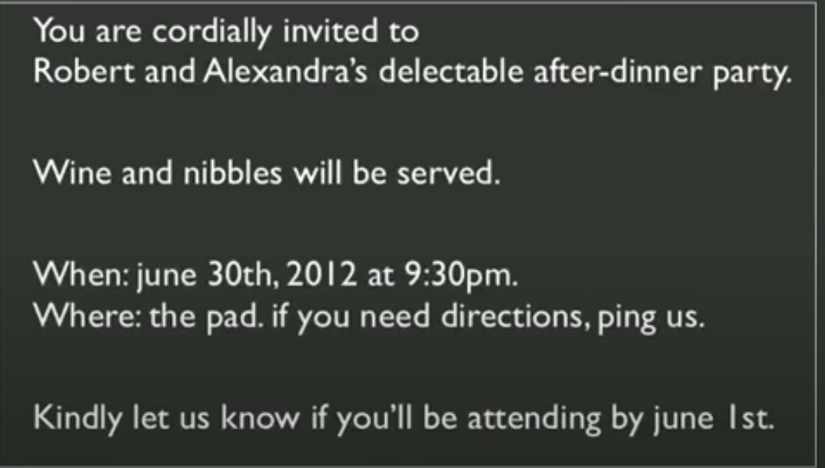
- Use different font size and weight
- 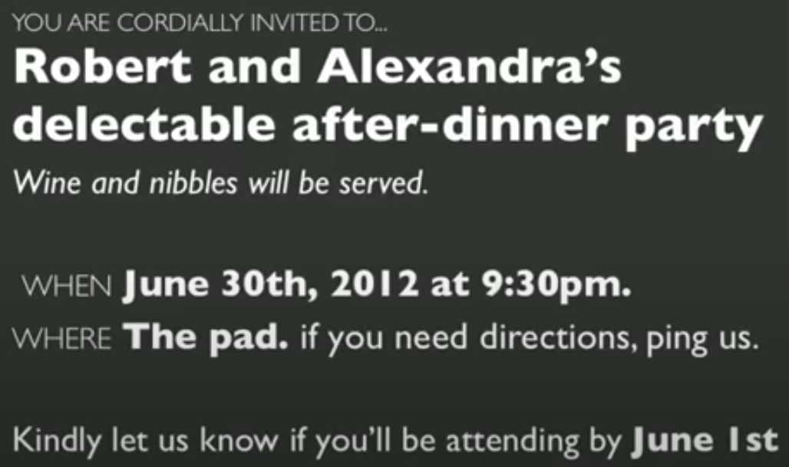
Visual Design - Three Goals -
- Guide
  - Convey structure, relative importance, relationships
- Pace
  - Draw people in, help orient, provide hooks to deep dive deep
- Message
  - Express meaning and style, breathe life into the content
3 Basic Tools - Visual Design
- Typography
- Layout
- Color

Video 3.2: Typography
- Letter forms thickness can differ
  - 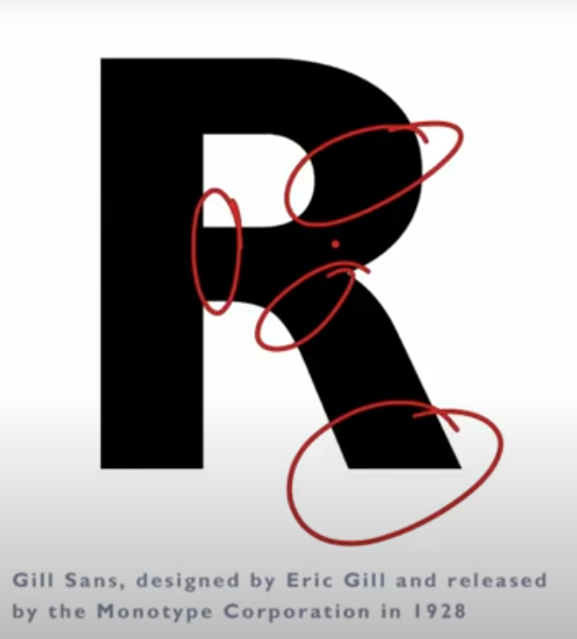
- Point size - (Font size)
  - Height of the lead block that was set in
  - 
  - Point size can differ between different fonts
  - 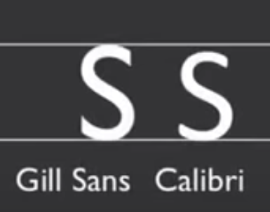
- Leading
  - customary to have 20% of your font size as your leading
  - 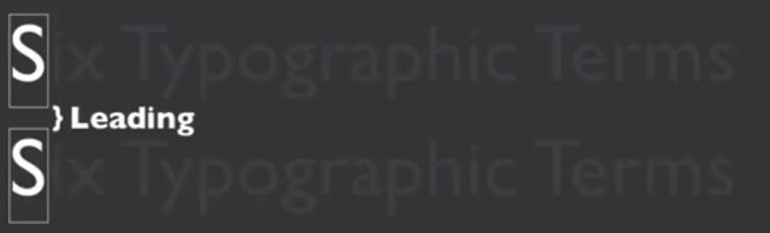
- X-height
  - the height of the lowercase letters is called the x-height
  - also different between fonts
  - 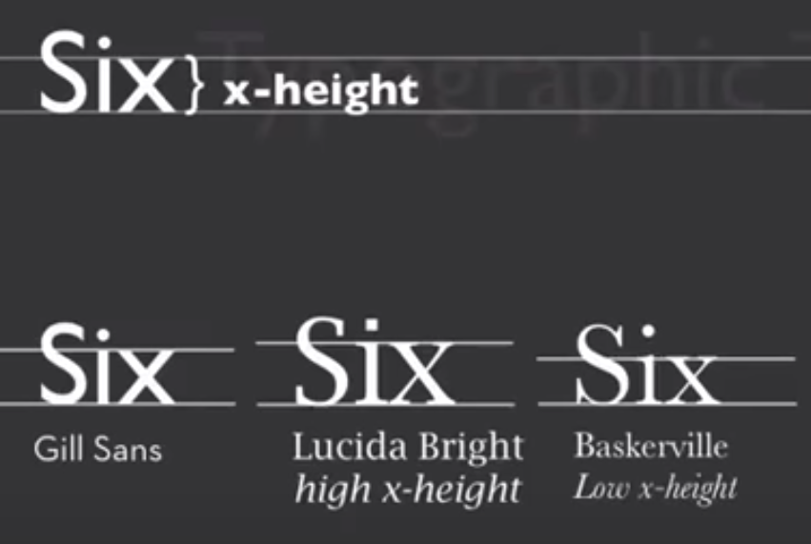
  - Typefaces that have a higher x-height will be easier to read at smaller sizes and on low resolution devices like mobile phones
Six Typographic Terms
- Ascenders and descenders
- 
- 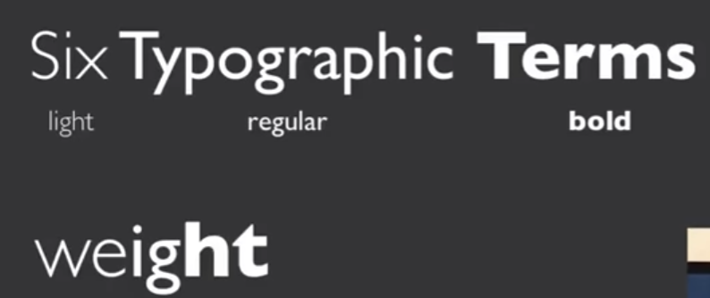
- 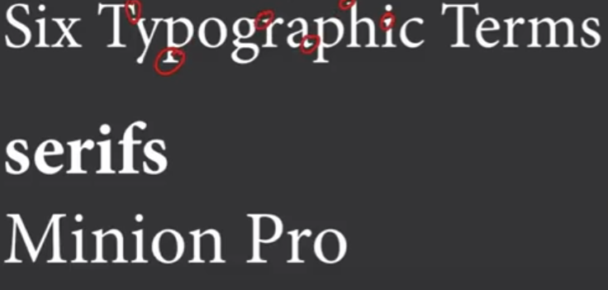
  - Serifs give the chiseld look (red circled)
- 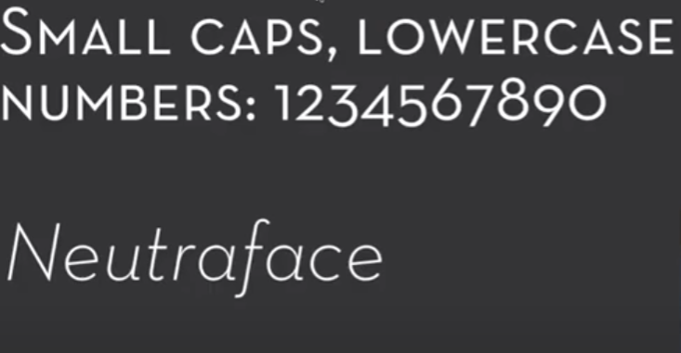
  - Smallcaps can be used as headers
- Serif typefaces are generally recommended for body text and sans-serif typefaces are recommended for headers
- 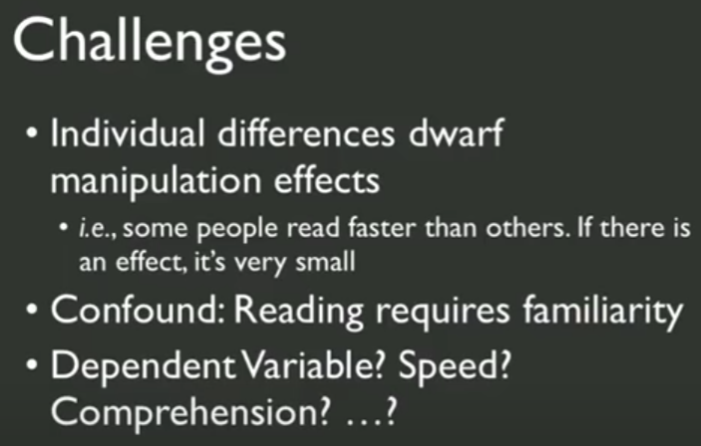
- 
- In practice legibility simply amounts to what you're accustomed to

- More information seems to be encoded in the top half of text than in the bottom half
- Expectation plays an important role in what you see
- Best to use type people are familiar with for text body
- Logos, signs and dramatic uses, then its better to use more unusual typefaces
- Testing Typefaces

  - 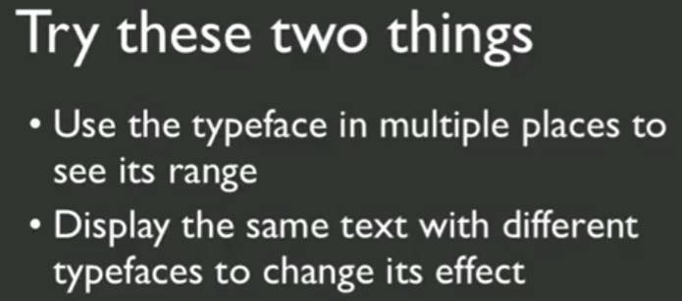

Video 3.3: Grids and Alignment
- 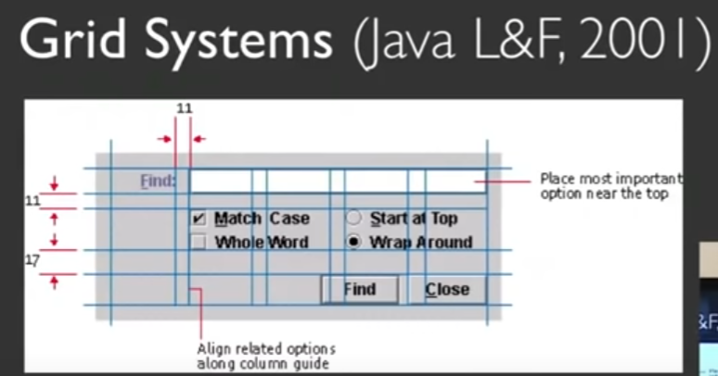
- Grid compromise of
  - main one is a set of columns
  - second is a set of gutters which is the white space in between the columns
- Alignment
- When creating template work on the longest text block first
- 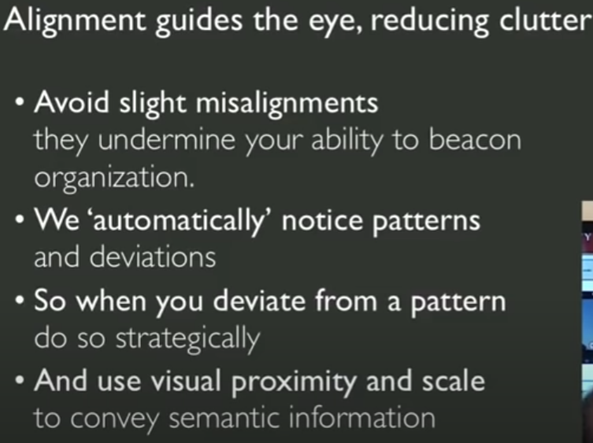
- When to use top, left, & right alignment
  - Amazon page as example
  - Address label - right aligned
  - 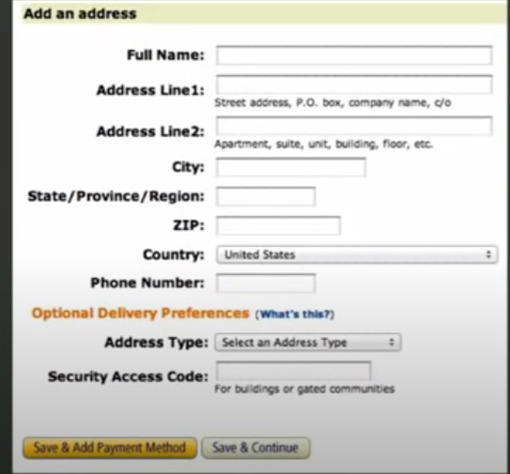
  - Account page - Left alignment
  - 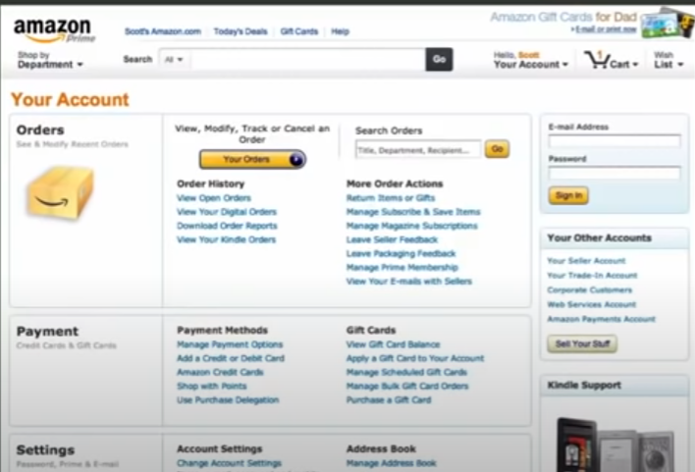
- Color
- 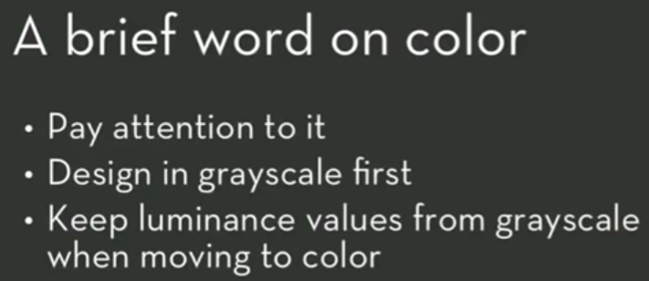
- 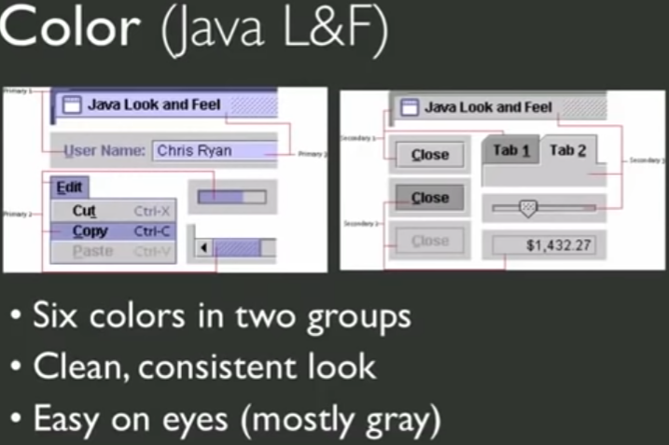
  - Purple color means you can click on
  - While gray color are unclickable
- Remember to whitespace
- 